Case Study - FORKOFF
AI Marketing Agency for Web3
1. Client Overview
FORKOFF is an AI-powered marketing agency operating at the intersection of artificial intelligence and Web3. The agency specialises in delivering data-driven brand campaigns, on-chain analytics, and automated content pipelines for blockchain-native projects serving a fast-growing clientele of DeFi protocols, NFT platforms, and Web3 start-ups worldwide.
To support its accelerating client growth, FORKOFF needed a scalable, resilient cloud platform capable of handling unpredictable traffic surges, automated media processing, and rapid iteration of its AI tooling — all without sacrificing reliability.
2. The Challenge
FORKOFF came to Kiwi Koru with a set of interconnected operational pain points:
- Unpredictable traffic spikes tied to token launches and viral campaign moments were overwhelming existing infrastructure, causing service degradation at precisely the worst times.
- Media processing for AI-generated content — video renders, image assets, and campaign creatives — was slow, manual, and bottlenecked by on-premise tooling.
- Deployment cycles were lengthy, inconsistent, and prone to human error, slowing the agency's ability to ship new AI features and respond to market opportunities.
- There was no unified content delivery layer, leading to high-latency asset serving for geographically distributed Web3 audiences.
- Operational data — campaign metrics, client usage records, and job queues — was scattered across disconnected systems with no reliable single source of truth.
3. The Solution
Kiwi Koru designed and delivered a fully serverless, cloud-native architecture tailored to FORKOFF's operational profile — elastic by design, secure by default, and built for the velocity of a modern AI agency. The solution spans compute, storage, media processing, delivery, and continuous deployment.
AWS Services Deployed
Service | Service
AWS Lambda | Amazon S3
AWS Elemental MediaConvert | Amazon CloudFront
Amazon API Gateway | Amazon DynamoDB
AWS CodePipeline

Architecture Highlights
Component | Role in Architecture
AWS Lambda & API Gateway | Event-driven serverless compute handles all inbound API traffic for FORKOFF's AI tooling and client-facing dashboards. Functions scale instantly to absorb traffic spikes, eliminating the need to provision or manage servers.
Amazon S3 | All campaign assets, AI-generated media files, and processed outputs are stored durably in S3 with lifecycle policies, versioning, and fine-grained access controls to support secure multi-client workflows.
AWS Elemental MediaConvert | Automated, serverless video transcoding pipelines convert AI-generated video content into multiple formats and resolutions on demand, triggered directly by S3 object events via Lambda.
Amazon CloudFront | A global CDN layer sits in front of all asset delivery, ensuring FORKOFF's Web3 clients receive low-latency content regardless of geographic location, with edge caching tuned per content type.
Amazon DynamoDB | A fully managed NoSQL database provides the operational backbone for campaign metadata, job-queue tracking, client usage records, and real-time status dashboards — with single-digit millisecond performance at any scale.
AWS CodePipeline | End-to-end CI/CD pipelines automate build, test, and deployment stages for all FORKOFF services. Releases are triggered on code commit, with staged approvals and automatic rollback on failure.

4. What Was Delivered
Workstream | Details
Serverless API Platform | End-to-end serverless API platform with Lambda and API Gateway, replacing fragile monolithic endpoints — with auto-scaling, per-function IAM roles, and structured logging.
Media Processing Pipeline | Automated pipeline: S3 → Lambda trigger → MediaConvert → CloudFront delivery, fully hands-off from ingest to distribution supports multiple output formats and resolutions on demand.
DynamoDB Data Model | Data model and access patterns designed for FORKOFF's campaign management, client onboarding, and job-tracking workflows optimised for single-digit millisecond performance at scale.
CloudFront Distribution | Global CloudFront distribution with custom cache behaviours, origin groups, and signed URLs for secure asset delivery ensuring low-latency performance for geographically distributed Web3 audiences.
CI/CD Pipeline (CodePipeline) | Fully automated CodePipeline CI/CD workflows covering all application services, with environment-specific deployment stages, test gates, and automatic rollback on failure.
Infrastructure as Code | Infrastructure-as-code for all resources, providing a reproducible, version-controlled environment baseline — enabling consistent deployments across development, staging, and production.
Operational Runbooks & KT | Operational runbooks, architecture documentation, and team knowledge-transfer sessions to ensure FORKOFF's engineering team could own and operate the platform post-handover.

4.1 Architecture Diagram
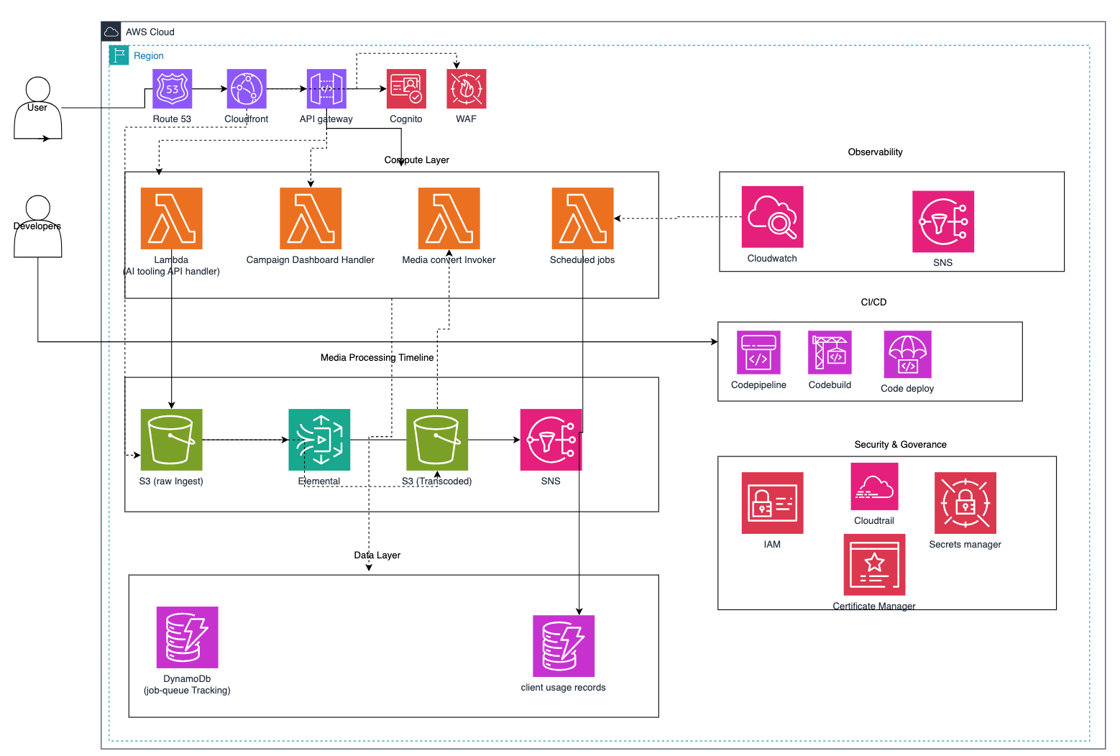
5. Outcomes & Impact
The new platform has fundamentally transformed how FORKOFF operates. The agency now deploys new features in hours rather than days, responds to viral campaign moments without service interruption, and delivers AI-generated media to clients anywhere in the world with consistent, low-latency performance.
The automated CI/CD pipeline through CodePipeline cut deployment cycle time by 60%, enabling the engineering team to ship updates with confidence and focus effort on product innovation rather than release coordination. Serverless autoscaling via Lambda and API Gateway means FORKOFF's platform absorbs 10× normal traffic volumes without manual intervention — critical during high-stakes token launch campaigns.
With 99.9% uptime maintained since go-live, FORKOFF's clients experience a rock-solid, always-available platform a meaningful competitive differentiator in the fast-moving Web3 marketing space.
Results Summary
Metric | Result
99.9% Platform Uptime | Platform availability sustained since go-live, ensuring FORKOFF's clients experience a rock-solid, always-available platform — a competitive differentiator in the fast-moving Web3 marketing space.
60% Faster Deployment | The automated CI/CD pipeline through CodePipeline cut deployment cycle time by 60%, enabling the engineering team to ship updates with confidence and focus on product innovation.
10× Traffic Spike Capacity | Serverless autoscaling via Lambda and API Gateway absorbs 10× normal traffic volumes without manual intervention — critical during high-stakes token launch campaigns.
Zero-Touch Media Processing | Automated media pipeline from S3 ingest through MediaConvert transcoding to CloudFront delivery — fully hands-off, reducing content processing time from hours to minutes.
Global Low-Latency Delivery | CloudFront edge distribution ensures AI-generated media reaches Web3 clients worldwide with consistent, low-latency performance regardless of geographic location.

6. About Kiwi Koru Limited
Kiwi Koru Limited is a cloud architecture and engineering consultancy helping technology companies design, build and operate scalable, resilient systems on AWS. We bring deep expertise in serverless architecture, real-time data platforms, media processing automation, and production infrastructure engineering.
Kiwi Koru Limited • Transforming business through cloud innovation

